C O U N T E R F E I T

NATURE VS NURTURE BY RIANNA NORBERT-DAVID

Smokescreen

By Ashley Scantlebury

Dearest friends they come and go,
start out pure then change, like blow.
Brother sister thick as blood,
beginning statues, ducks and mud.
Now incest pools all intertwined,
me with yours and you with mine.
Suspect cesspool, cesspit, rancid,
randy ravers, raunchy, candid.
We’re meant to be! Now number four,
but all is fair in love and war.
The knives are out without the shields,
they know too well your Achilles heel.

Amongst the soil there might be one,
emerald, ruby, one diamond.
One who’s soul embraces yours,
one who rarely sharpens claws.
And of that one sweet words might fly,
and see sweet truths, not pride in lies.
These are friends and only these,
but embrace still your enemies.
For hate should not reside within,
It weakens hearts and cracks your skin.

Brother sister sharp and quick.
Foxy insults masked with wit.
Distant friends, my life's competitors,
first class standards, constant comparisons.
Engulfed.
Gobbled up, by cyber thumbs and yummy mums.
Red lips, bombers, chunky chains,
Shackle locked down to the grain.
Ego's swollen menstral mates,
take impostors out on dates.
No new friends and girls aren't loyal,
Sorry world but that's a pile-
Of shit. And boy does that quite stink-
it's high way to gucci, or Louis or Lambo
not dinning in Nandos, the season has changed.

What reason resides amongst western debris
to focus entirely on money?
What health's in wealth? When sex was stealth?
What books? Pick looks and dwell in hell.
Society is not for me,
Technology and shopping sprees
I lose myself each time I spend,
And wish "wanna look rich" would end,
I want to know a friend that's true,
no mirror magnets making moves.
I want to leave, I need to breathe
and speed through high ways on my feet.
I Nudely, rudely strip the page,
lose the baboons, lose the cage.

P E R F E C T I O N
B Y A S H L E Y S C A N T L E B U R Y

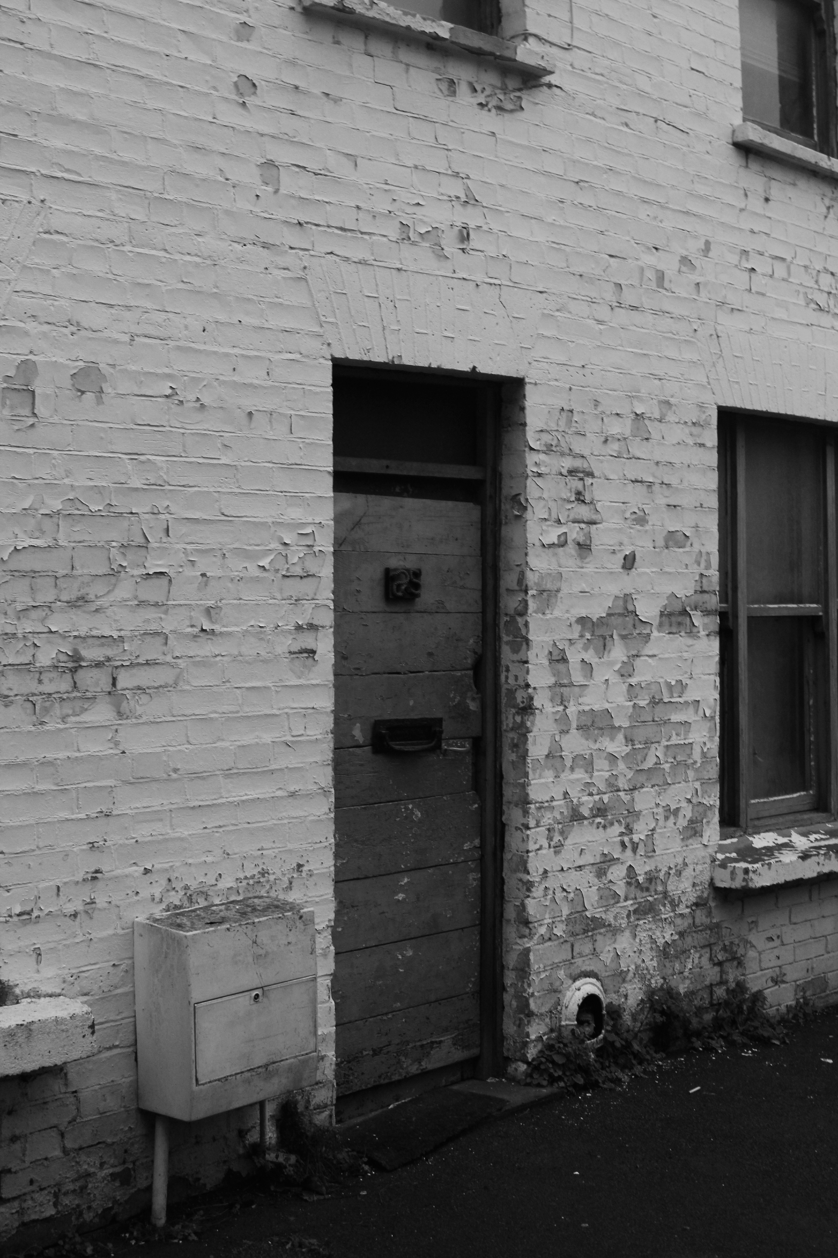
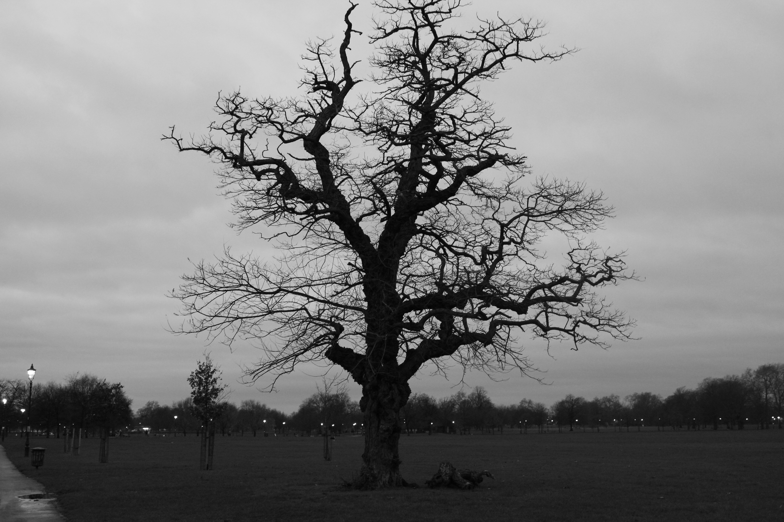

S.O.S
By Mei THE Music

Verse 1
The sound of pencil across my diary
The sound of traffic from the busy street
The sound of one heartbeat and laboured breathing
Orchestrated to lament my feelings

A bed that locks me into a submission
A lamp that exposes all my flaws
A door that stops the whole world from ever hearing
The orchestrated lament of my feelings
A symphony of sound waves drown out my dreams

Chorus
As I isolate myself
All these sound waves form to make my cell
And now I’m locked up in perfection’s hell
Where nothing I do is ever good enough

Verse 2
The sound of aeroplanes that leave me behind
The sound of TVs cheer when someone shines
The sound one heartbeat and silent weeping
Orchestrated to lament my feelings
A symphony of sound waves drown out my dreams

Chorus
As I isolate myself
All these sound waves form to make my cell
And now I’m locked up in perfection’s hell
Where nothing I do is ever good enough

Untouched

By Sade Joseph Moreira Costa

Wandering through forgotten deserts
and untouched villages,
winds sweeping hair off her face to reveal
perfection,
the quartz within her eyes refracting the light beamed upon her.
She walks with poise and grace
words fall with eloquence,
carried away on a calm breeze,
inspiring the masses to storm.
She is my perfect self,
warrior,
lover,
arms bound in leather
concentric circles towards my heart.
I write her love letters,
her biggest fan.
I'm anxious to meet her-
to greet her.
I used to see her in my dreams,
pigtails- wrapped in white cloth
to lay my head on a pillow.
To dream of her
beautiful browns merging with gold adornments,
which punctuate the chocolate
cocoa,
skin.
She is a queen,
not needing a crown or a sceptre.
The glow she emits,
she must be created from gold.
She whips the desert into a frenzy,
sandblasting her way through the sediments of insecurity pressured
within my soul.
We are chunks of marble,
which hold masterpieces.
Sculpting cliff faces to search for diamonds.
When molten gold pours through our veins.
Chipped cliff
blends with torn flesh,
perfection obscured.

W A R P E D

B Y E F U A B O A K Y E

We’ve Gone Too Far

By Aeve Ribbons

Perfection is she,
for a second.

She radiates beauty and joy from behind her plastic shield,
carefully affixed so as to protect her from the dirty rain.

Her paperwhite teeth lie between delicate lips smile into caramel skin framing almond ocean eyes staring -
those eyes seduce you, you with your envy,
and whisper in your mind:
“You could look like this too, for only nineteen pounds ninety-nine,”
Or perhaps that is the white writing speaking to you and everyone from across her naked shoulders
Or the way her silk skin reflects the invisible studio lights:
unblemished unwrinkled perfect impossible skin
Aphrodite skin Venus skin
And yes, perhaps your skin, if...
(You are familiar with the message)

Perfection is she,
for this second.
Until something not quite right,
something unsettling, wrong
trapped amidst her designed perfection,
catches your eye just slightly.

Something out of place is
giving away the pointless irresistible lie of her face,
the lie we all know
yet all fall victim to, as if it were truth.

Always seduced, despite ourselves.
(It’s understandable: rationality doesn’t have such alluring eyes)
It almost shares flawless beauty with the rest of what is now
almost-perfect-woman-image
But like a disfigured jigsaw piece failing to tessellate, it jars:
lonely flaw in a shrine to the infallible.
But this is not fault from nature: it is not one of life’s scars, or blemishes, slipped through the net.

No, this fault is theirs: they’ve done it again.
They’ve exposed themselves again,
Destroyers of ugly human imperfection,
wonky wobbly flyaway scarred real human.
The clicking murderers of life’s imprints.

We push and continue to push them,
narrowing the borders of beauty, hiding it with Photoshop Lies and symmetrical lines,
and now they’ve exposed it all again.

They’ve circled and brushed and clicked and smoothed away every imperfection their eyes can find,
even the ones they can’t
but they’ve lost sight of Real,
and now her ear is giving it all away.

“I wonder what it’s like to hear
when half of your ear has been airbrushed out of existence”
you think.

T H E B E A S T A N D H E R I N N E R B E A U T Y
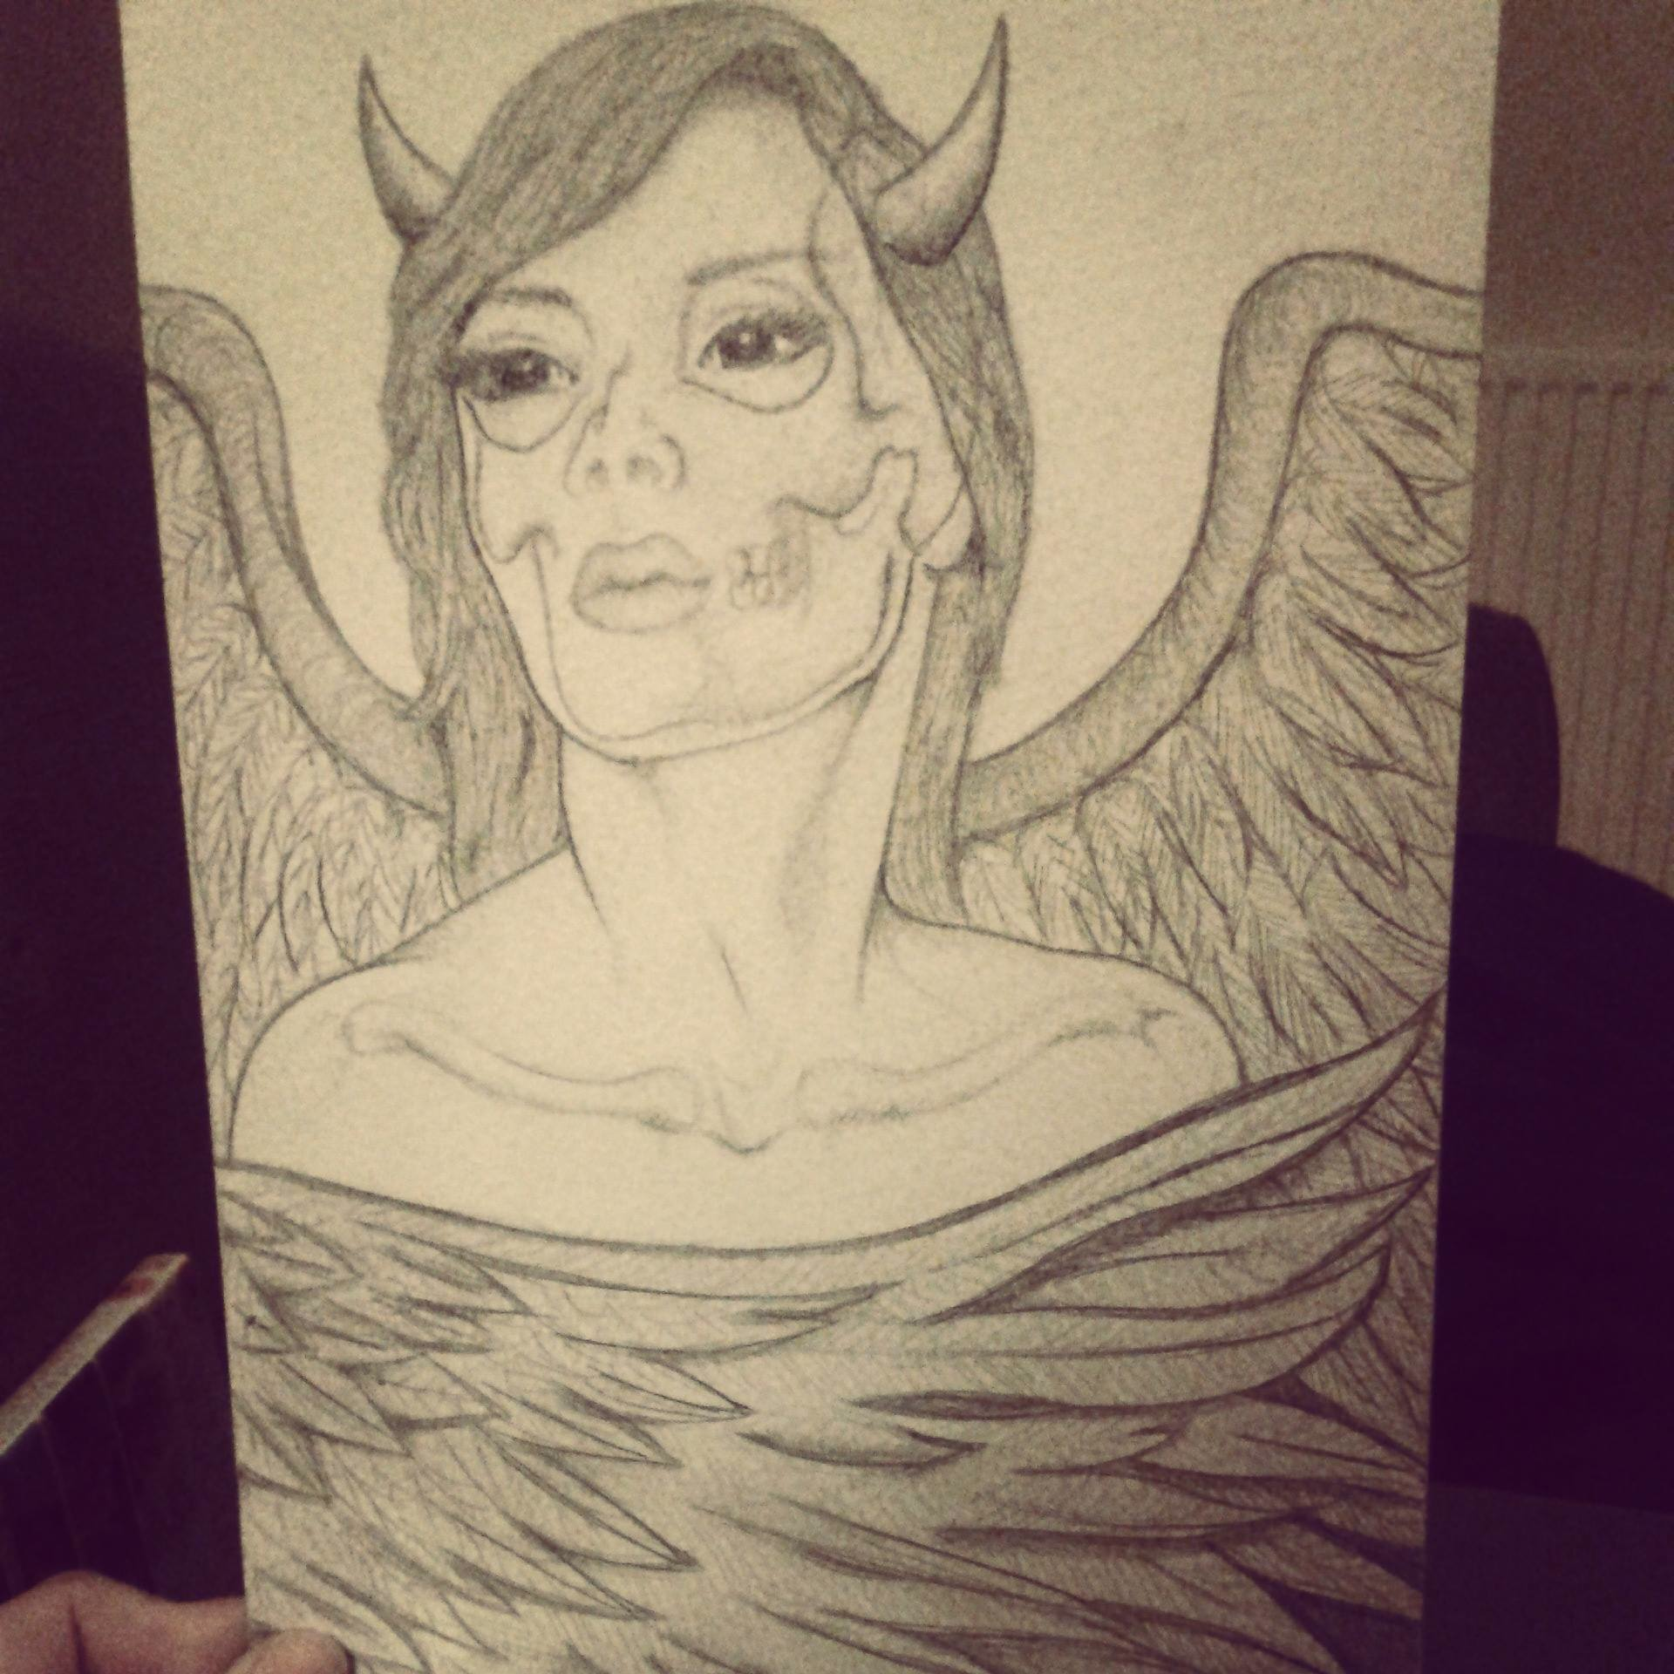
B Y I N E S C A S T E L L O

